
STUDENT CASE STUDY EXECUTION REPORT
Department | FED
Subject | DSA -2
Academic year | I – III Semester(2025-26)
Faculty Name | V. GopiKrishna
Student Name | K. Sriram
Roll Number | 2520040072
Branch | ECE
Course Outcome | 5

Case Study Topic : EventSphere Event Popularity Ranking using Quick Sort
EventSphere is a smart event planning and management system used to manage events, participant registrations, venue scheduling, and analytics.
During a technical fest, multiple events receive registrations from participants.
To display the most popular events first, EventSphere sorts events based on registration count.
For one event day, registrations are:
Event | Registrations
Music Fest | 120
Workshop | 300
Tech Talk | 90
Hackathon | 450
Project Expo | 210
The system must rank events in descending order.
Quick Sort is used.

Question
Using the EventSphere popularity scenario:
- Store registration counts
- Apply Quick Sort
- Sort descending order
- Display ranked events
- Calculate worst-case time
- Explain why Quick Sort is suitable

Analysis & Implementation

1.1 Registration data
Inserted:

120
300
90
450
210

Quick Sort:
- choose pivot
- partition array
- recursively sort
Before sorting:

120 300 90 450 210

After sorting:

450 300 210 120 90

1.2 Ranking
Event ranking:

1. Hackathon – 450
2. Workshop – 300
3. Project Expo – 210
4. Music Fest – 120
5. Tech Talk – 90

Highest popularity appears first.

1.3 Time complexity
Average:

O(n log n)

Worst:

O(n²)

For EventSphere:
Fast sorting for medium and large event data.

1.4 SLA calculation
Given:
- one comparison = 200 ns
- budget = 5 ms
Approximate:

5 × log₂5 ≈ 12 operations

Worst-case:

12 × 200 ns = 2400 ns

Convert:

2400 ns = 0.0024 ms

Percentage:

(0.0024 / 5) × 100
= 0.048%

System satisfies SLA.

1.5 Why Quick Sort is suitable
Advantages:
- fast sorting
- efficient partitioning
- useful for ranking
- handles large arrays
- simple implementation
For EventSphere:
- event popularity ranking
- display trending events
- analytics reporting

2. Final reasoning
For EventSphere:
- registrations sorted correctly
- top events shown first
- fast execution
- scalable ranking
Quick Sort is suitable for popularity-based event ranking.

Code:
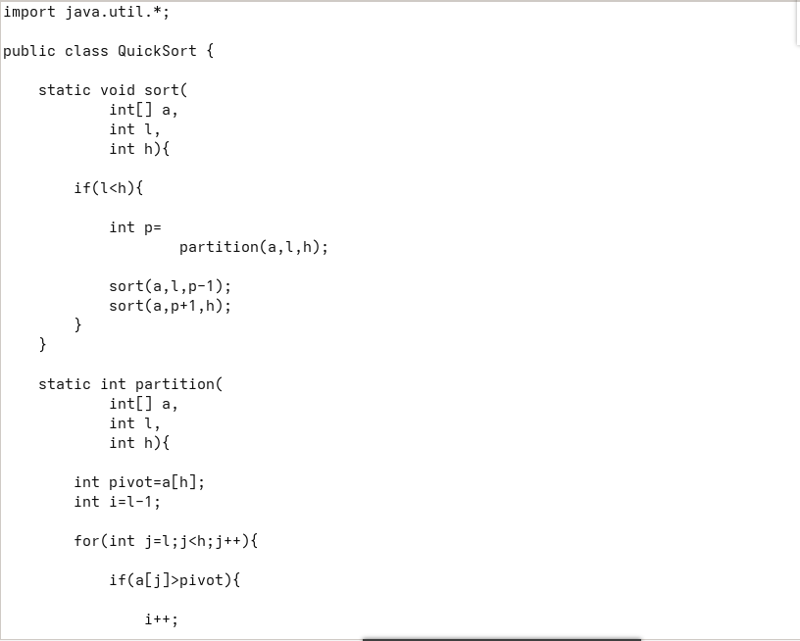
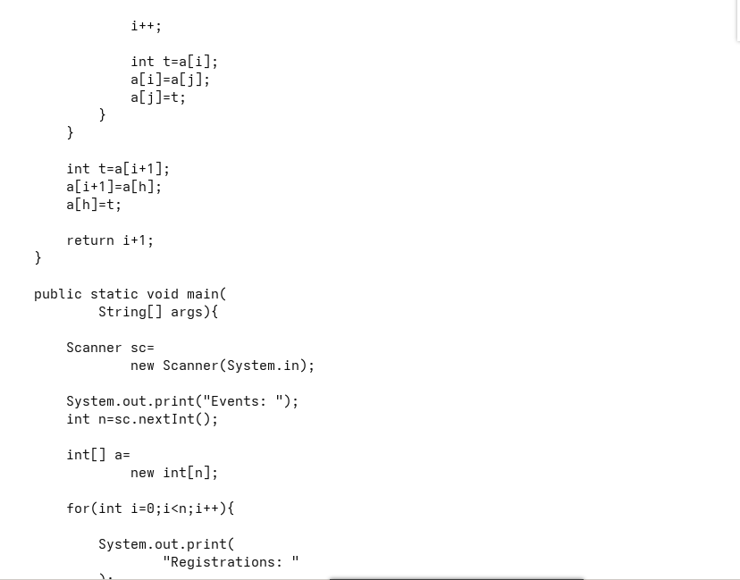

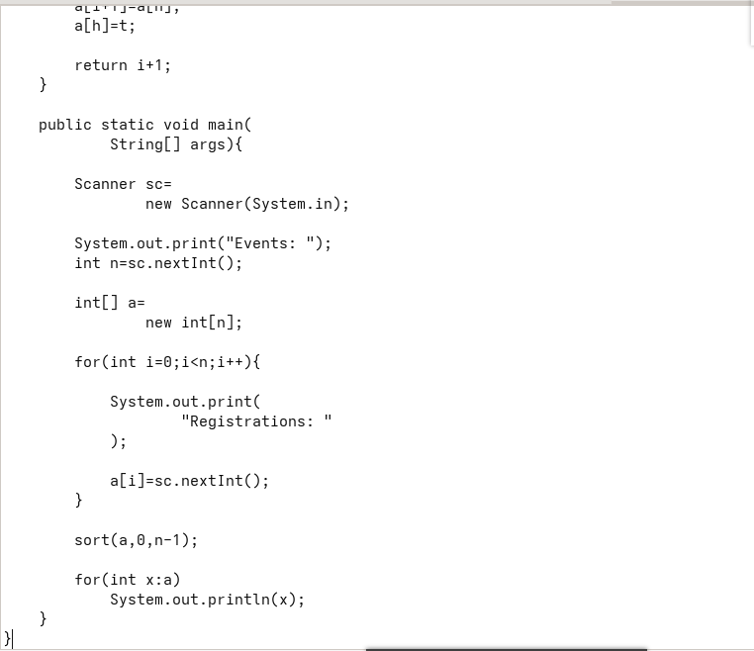
Output:

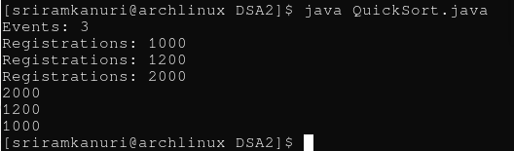

GitHub Link: https://github.com/kanurisriram/EventSphere

Student Signature | Faculty Signature
____________________ | ___________________

